# Title page

Title: Specific clusters of fatty acids within the serum triacylglycerol fraction associate with the pathogenesis of type 2 diabetes

Author: Luke W. Johnston, MSc (1); Zhen Liu, PhD (1); Ravi Retnakaran, MD (3,4); Bernard Zinman, MD (3,4); Adria Giacca, PhD (5); Stewart B. Harris, MD (2); Richard P. Bazinet, PhD (1); and Anthony J. Hanley, PhD (1,3,6)

Affiliation:

1. Department of Nutritional Sciences, University of Toronto, Toronto, Ontario, Canada.
2. Centre for Studies in Family Medicine, University of Western Ontario, London, Ontario, Canada.
3. Leadership Sinai Centre for Diabetes, Division of Endocrinology, University of Toronto, Toronto, ON, Canada.
4. Lunenfeld Tanenbaum Research Institute, Mount Sinai Hospital, Toronto, Ontario, Canada.
5. Department of Physiology, University of Toronto, Toronto, Ontario, Canada.
6. Dalla Lana School of Public Health, University of Toronto, Toronto, Ontario, Canada.

Corresponding author:

* Name: Anthony J. Hanley
* Current address:  
  Department of Nutritional Sciences  
  Faculty of Medicine  
  University of Toronto  
  FitzGerald Building, 150 College Street, Room 341  
  Toronto, ON, Canada, M5S 3E2
* Phone number: 416.978.3616
* Fax number:
* Email: [anthony.hanley@utoronto.ca](mailto:anthony.hanley@utoronto.ca)

Disclaimers:

Funding support:

Word count: ~4000

# Abstract

Word count: 249 / 250

**Objective**: Although elevated serum triglyceride (TAG) is a well-described risk factor for type 2 diabetes (T2DM), few data are available regarding the role of the specific fatty acid composition within serum TAG (TAGFA) in the pathogenesis of T2DM. Our aim, therefore, was to examine longitudinal associations of TAGFA with insulin sensitivity (IS) and beta-cell function.

**Research Design and Methods**: We used longitudinal data (3 visits over 6 years) from the Prospective Metabolism and Islet Cell Evaluation (PROMISE) cohort of adults (n=477) who were at-risk for diabetes at baseline. Glucose and insulin from an OGTT were used to calculate the following outcome variables: Matsuda index (ISI), HOMA2-%S, Insulinogenic Index over HOMA-IR (IGI/IR), and Insulin Secretion-Sensitivity Index-2 (ISSI-2). Gas chromatography quantified TAGFA composition. Generalized estimating equations (GEE) adjusted for confounders and partial least squares (PLS) were used for the analysis.

**Results**: The outcome variables declined by 14% to 27% over the 6-years. In the adjusted GEE models, four TAGFA (14:0, 16:0, 14:1n-7, 16:1n-7 as mol%) had strong negative associations with IS while others (e.g. 18:1n-7, 18:1n-9, 20:2n-6, 20:5n-3) had strong positive associations. Few associations were seen for beta-cell function, except for 16:0 (negative) and 18:1n-7 (positive). PLS analysis indicated four TAGFA (14:0, 16:0, 14:1n-7, 16:1n-7) that are markers of de novo lipogenesis (DNL) clustered together and strongly predicted lower IS. These four TAGFA also correlated highly (r>0.4) with clinically measured TAG.

**Conclusions**: We found that higher proportions of a cluster of four DNL TAGFA strongly predicted lower IS as well as hypertriglyceridemia.

# Background

Hypertriglyceridemia is a well described metabolic disorder resulting in negative health outcomes (1). It is a strong risk factor for cardiovascular disease (2,3) and is associated with other metabolic disorders such as non-alcoholic fatty liver disease (4), the metabolic syndrome (5), and abdominal obesity (6). Circulating triacylglceride (TAG) concentration is commonly measured during routine clinical assessment using enzymatic methods. However, clinically measured TAG is limited as it represents the full fatty acid spectrum within the TAG fraction as a summary measure. There is increasing appreciation for the importance of specific fatty acid composition profiles in different plasma fractions on various health outcomes (7–9), however there are relatively few studies that have explored the impact of the fatty acid composition in the TAG fraction (10,11).

The interaction between TAG and insulin sensitivity is complex and involves components of a feedback system (3). Greater resistance to insulin in both the liver and muscle may result in greater production of TAG and secretion of lipoproteins that transport TAG (12). Likewise, greater TAG may contribute to metabolic dysfunction and lipotoxicity in various tissues affecting insulin sensitivity , and thus continue the cycle (3). Given the complexity and temporal nature of the relationship, long term studies with multiple data collection time points are paramount to better understanding the underlying biology and subsequent risk.

While several studies have documented prospective associations of hypertriglyceridemia with incident type 2 diabetes (2,13,14), only a limited number of longitudinal studies (10,11) have examined the relationship between TAG and its composition with the pathophysiological factors underlying diabetes, particularly beta-cell function. Our objective was to examine the longitudinal role of the specific composition of the serum TAG fraction on OGTT-derived measures of insulin sensitivity and beta-cell function compared to clinically measured TAG in a Canadian population at risk for diabetes.

# Subjects and Methods

Recruitment for the baseline visit of the Prospective Metabolism and Islet Cell Evaluation (PROMISE) cohort took place between 2004-2006 in London and Toronto, Canada. Individuals were selected to participaye if they met the eligibility criteria of having one or more risk factors for type 2 diabetes mellitus, including obesity, hypertension, family history of diabetes, and/or a history of gestational diabetes or birth of a macrosomic infant. A total of 736 individuals attended the baseline visit. Subsequent examinations occurred every three years, with data from three examination visits available for the present analysis (2004-2006, 2007-2009, and 2010-2013). The current study used data on participants who did not have diabetes at baseline, who returned for one or more of the follow-up examinations, and who had samples available for fatty acid measurements (n=477; see the CONSORT diagram in Supplemental Figure 1). Metabolic characterization, anthropometric measurements, and questionnaires on lifestyle and sociodemographics were administered at each examination visit. Research ethics approval was obtained from Mount Sinai Hospital and the University of Western Ontario, and all participants provided written informed consent. Data collection methods were standardized across the 2 centres and research nurses were centrally trained.

## Metabolic characterization

After 8-12 hours of overnight fasting, participants completed a 75g oral glucose tolerance test (OGTT) at each examination visit, with blood samples taken at fasting, 30 min, and 2 hr post-glucose load. Samples were subsequently processed and frozen at -70°C. Alanine aminotransferase (ALT) was measured using standard laboratory procedures. Cholesterol, HDL, and clinically-measured TAG were measured using Roche Modular's enzymatic colorimetric tests (Mississauga, ON). Both insulin and glucose were measured from OGTT blood samples at fasting, 30 minute, and 2 hour time points. Specific insulin was measured with the Elecsys 1010 (Roche Diagnostics, Basel, Switzerland) immunoassay analyzer and electrochemiluminescence immunoassay, which shows 0.05% cross-reactivity to intact human pro-insulin and the Des 31,32 circulating split form (Linco Res. Inc) and has a coefficient of variation (CV) of 9.3%. Glucose was determined using a kit based on an enzymatic hexokinase method (Roche Modular, Roche Diagnostics) with a detection range of 0.11 to 41.6 mmol/L and an inter-assay CV of <1.1% and an intra-assay CV of < 1.9%. All assays were performed at the Banting and Best Diabetes Centre Core Lab at Mt Sinai Hospital. Impaired fasting glucose (IFG), impaired glucose tolerance (IGT), and diabetes were categorized using the 2006 WHO criteria (15).

TAGFA composition was quantified using stored fasting serum samples from the baseline visit, which had been frozen at -70°C for 4-6 years and had not been exposed to any freeze-thaw cycles. Serum fatty acids have been documented to be stable at these temperatures for up to 10 years (16). A known amount of triheptadecanoin (17:0; Nu-Chek Prep, Inc Elysian, MN, USA) was added as an internal standard prior to extracting total lipids according to the method of Folch (17). Each serum lipid fraction (non-esterified fatty acids (NEFA), cholesteryl ester, phospholipid, and TAG) was isolated using thin layer chromatography. Fatty acid methyl esters were separated and quantified using a Varian-430 gas chromatograph (Varian, Lake Forest, CA, USA) equipped with a Varian Factor Four capillary column and a flame ionization detector. Fatty acid concentrations (nmol/ml) were calculated by proportional comparison of gas chromatography peak areas to that of the internal standards (18). There were 22 fatty acids measured in the TAGFA fraction. Findings for other lipid fractions in this cohort are reported separately (see ref (9) for the analysis of the phospholipid and cholesteryl ester fractions). PUT TOGETHER IN DISCUSSION

## Anthropometrics and sociodemographics

Height, weight, and waist circumference (WC) were measured at all clinic examinations using standard procedures. WC was measured at the natural waist, defined as the narrowest part of the torso between the umbilicus and the xiphoid process. BMI was calculated by dividing weight (kg) by height (m) squared. Questionnaires administered at each examination determined sociodemographics. A version of the Modifiable Activity Questionnaire (MAQ) (19) determined estimated physical activity. The MAQ collects information on leisure and occupational activity, including intensity, frequency, and duration, over the past year. Each reported activity from the MAQ was weighted by its metabolic intensity allowing for the estimation of MET-hours per week (19).

## Variable calculation and statistical analysis

Insulin sensitivity and beta-cell function indices were computed using the OGTT glucose and insulin data. Insulin sensitivity was assessed using the Insulin Sensitivity Index (ISI) (20) and HOMA2-%S (21) using the HOMA2 Calculator. HOMA largely reflects hepatic insulin sensitivity, while ISI reflects whole-body insulin sensitivity (22). Beta-cell function was assessed using the Insulinogenic Index (23) over HOMA-IR (24) (IGI/IR) and the Insulin Secretion-Sensitivity Index-2 (ISSI-2) (25). IGI/IR is a measure of the first phase of insulin secretion while ISSI-2 is analogous to the disposition index (but is calculated using OGTT values). Each index has been validated against gold standard measures (20,24–26). Specific formulas for each OGTT-derived measure can be found in the Supplemental Material. WHERE? I COULD not FIND IT

The primary outcome variables for this analysis were HOMA2-%S, ISI, IGI/IR, and ISSI-2, which were log-transformed for the statistical modeling. The primary predictor variables for this analysis were 22 individual TAGFA included as either mole percent (mol%) of the total fraction or as a concentration (nmol/mL). Clinically-measured TAG was also included as a primary predictor to allow us to test the hypothesis that specific TAGFA better predicted outcomes compared to clinical TAG. Pearson correlation coefficients were computed to assess the relationships of individual TAGFA with other continuous variables. Correlations were also computed for TAGFA against each other; hierarchical clustering analysis was applied to the correlation matrix to identify potential clusters within the TAGFA composition DESCRIBE BETTER NOT CLEAR TO ME HOW THIS IS DONE.

Generalized estimating equation (GEE) models (27) were used in the primary analysis to determine the longitudinal associations between the outcome variables and the predictor variables. The predictor variables and continuous covariates were scaled (mean-centered and standardized). Given the longitudinal design, an auto-regressive of order 1 (AR1) working correlation matrix was specified in the GEE model. Covariates to adjust for were selected based on the previous literature, from directed acyclic graph (28) recommendations, and from quasi-likelihood information criteria (QIC). The final GEE model was adjusted for time, waist circumference, baseline age, ethnicity, sex, ALT, MET, and total NEFA. THAT IS WHICH ONE WAS USED M6? FOR BETA CELL? The TAGFA, total NEFA, sex, ethnicity, and baseline age were classified as *time-independent* (held constant) as they were measured only at the baseline visit or do not change throughout the study, while the outcome variables and remaining covariates were set as *time-dependent*. After transformations, the GEE estimates are interpreted as an expected percent difference in the outcome variable for every standard deviation (SD) increase in the predictor variable given the covariates are held constant (including time). We also tested for an interaction with sex, ethnicity, or time by the predictor term for each outcome variable. See the Supplemental Methods for an expanded explanation of the GEE modeling analysis.

While GEE accounts for the longitudinal design of the data, this approach is limited in that it cannot analyze the inherent multivariate nature of the composition of the TAGFA fraction. Therefore, to confirm the GEE results in a multivariate environment (i.e. all TAGFA analyzed collectively), partial least squares regression (PLS) was used to identify the patterns of TAGFA composition against insulin sensitivity and beta-cell function as outcome variables. For a detailed explanation of PLS see the Supplemental Methods. Briefly, PLS is a technique that extracts latent structures (clusters) underlying a set of predictor variables conditional on a response variable(s) (i.e. the outcome variables). How accurately the clusters within the TAGFA composition predict metabolic function is determined by using cross-validation on the PLS models.

All analyses were performed using R 3.3.1 (29), along with the R packages geepack 1.2.1 for GEE (30) and pls 2.6.0 for PLS. The R code and extra analyses for this manuscript is available at {{code doi}}. Results were considered statistically significant at p<0.05, after adjusting for multiple testing using the Benjamini-Hochberg False Discovery Rate (31). STROBE was used as a guideline for reporting (32).

# Results

## Basic characteristics of the PROMISE cohort

Table 1 shows basic characteristics of the PROMISE cohort. The mean follow-up time was 5.6 (1.0) years, where 88.7% of participants attended all three visits. There were 349 (73.2%) females and 336 (70.4%) who had European-ancestry, with a mean age in years of 50.1 (9.8) and a mean BMI of 31.1 (6.4) kg/m2. As expected from the study's eligibility criteria, the majority of participants, n=308 (64.8%), had a family history of diabetes. Between the baseline visit and the 6-year visit in this sample, insulin sensitivity and beta-cell function measures had a significant median decline of between 14% to 27% (p<0.001 from GEE; n=367-470). There were 96 (20%) and 42 (9%) incident cases of pre-diabetes (IFG and IGT) and diabetes, respectively, over the 6-years; these observations were excluded from GEE and PLS analyses. Why?

Figure 1 shows the composition of each FA in the TAG fraction (see Supplemental Table 2 for a tabular presentation of the values). Three TAGFA contributed 82.4% to the total TAG concentration: 18:1n-9 (37.8%); 16:0 (26.6%); and, 18:2n-6 (18.0%). Figure 2 shows a heatmap of the correlation of individual TAGFA as concentrations with the outcome variables and several basic characteristics. As expected, nearly all TAGFA had very strong positive correlations (r= 0.33 to 0.92) with clinically-measured TAG and moderate positive correlations with WC (r=0.31 to 0.36). There were also moderate negative correlations with HDL (r=-0.53 to -0.32). For the outcome variables, the correlations for the insulin sensitivity measures were generally higher (HOMA2-%S: r=-0.48 to -0.32, ISI: r=-0.48 to -0.33) than for the beta-cell function measures (all r<0.30). For correlations of individual TAGFA using mol% with the basic participant characteristics, as shown in Figure 3, differences in correlations between fatty acids were most evident for 14:0, 14:1n-7, 16:0, and 16:1n-7 that had a moderate positive correlation with clinical TAG (r=-0.5 to -0.31) while all other fatty acids had a negative association (r=0.42 to 0.52). In particular, those fatty acids with the negative associations with clinical TAG were all the very long chain polyunsaturated fatty acids (e.g. 20:4n-6, 20:5n-3). Based on heirarchical cluster analysis of the inter-correlation matrix of the TAGFA fraction, shown in Figure 4, four fatty acids (14:0, 16:0, 14:1n-7, and 16:1n-7) displayed a marked separation and cluster from the other TAGFA. I CAN”T INTERPRET FIGURE BASED ON THE INFO GIVEN

## Generalized estimating equation models

Results from the unadjusted GEE model are shown in Figure 5 and for the adjusted GEE model in Figure 6. The majority of associations with beta-cell function measures were attenuated after full model adjustment, while nearly all associations with insulin sensitivity remained significant for both mol% and nmol/mL results. Subsequent analysis revealed that the attenuation with beta-cell function was due primarily to adjustment for waist.

In analyses using concentration values, nearly all TAGFA had a strong negative association on HOMA2-%S and ISI (estimates of percent different ranging from -13.7 to -3.6 and -14.7 to -4.4, respectively), and a few had strong negative associations with IGI/IR and ISSI-2 (estimates ranging from -7.4 to -7.3 and -4.1 to -3.4, respectively). In analyses using TAGFA mol% values, four TAGFA (14:0, 16:0, 14:1n-7, and 16:1n-7) had negative associations with HOMA2-%S and ISI (between -11.6 to -5.7 and -12.3 to -5.8, respectively, lower insulin sensitivity for every SD increase in the TAGFA), while several more TAGFA had positive associations with HOMA2-%S and ISI (20:0, 18:1n-9, 20:1n-9, 22:1n-9, 18:2n-6, 20:2n-6, 20:4n-6, and 22:5n-3) predicting between 4.3 to 14.2 and 5.8 to 15.2%, respectively, higher insulin sensitivity for every SD increase in the TAGFA. One TAGFA, 20:2n-6, had a very strong positive association with the insulin sensitivity measures, with a 14.2 to 15.2% higher insulin sensitivity for every SD increase. Both clinically-measured TAG and total TAGFA concentration had very strong negative associations with all outcome variables.

While there were a few significant interactions by time in unadjusted models, after inclusion of covariates in the model, these interactions were attenuated (data not shown). There were no significant interactions by sex or ethnicity for any of the TAGFA (data not shown). Results of the sensitivity analyses identifying waist circumference as the covariate that attenuated the beta-cell function associations from the unadjusted model are shown in Supplemental Figure 4. A tabular presentation of the GEE results is shown in Supplemental Table 3 for unadjusted models and Supplemental Table 4 for adjusted models.

## Clustering of TAGFA by metabolic measures

The PLS analysis corroborated the findings from the GEE models. The PLS results conditioned on insulin sensitivity as the outcome (MEANING DESCRIBE BETTER NOT CLEAR TO ME HOW THIS IS DONE) showed a clustering of the fatty acids 14:0, 14:1n-7, 16:0, and 16:1n-7 as mol% (Figure 7). . I CAN”T INTERPRET FIGURE BASED ON THE INFO GIVEN

These TAGFA loaded strongly and negatively on HOMA2-%S and ISI in the first component, suggesting this cluster of TAGFA tracks together with lower insulin sensitivity. The TAGFA 20:2n-6, 20:5n-3, 22:5n-3, and 22:6n-3 loaded positively on both insulin sensitivity measures. No other TAGFA loaded strongly. In the second component, 18:1n-9 and 18:1n-7 loaded positively but not strongly while 20:5n-3 and 22:6n-3 loaded strongly and negatively with both HOMA2-%S and ISI; however, this component only explained <10% of the variance. The PLS model for insulin sensitivity had good predictive ability, with a high correlation between the predicted outcome values against the observed values (HOMA2-%S: r=0.46, p<0.001; ISI: r=0.39, p<0.001).

The beta-cell function PLS results showed a similar clustering of fatty acids, however there was a lower correlation (though significant at p<0.001) between the predicted values and the observed values (r=0.25 to 0.24), suggesting that TAGFA composition poorly predicts beta-cell function. Given the low predictability, only the insulin sensitivity measures are presented. We used the extracted PLS scores as the predictor variable in the GEE models and found negative associations of the first component on all outcome variables, with the strongest association being with the insulin sensitivity variables (beta=10.2, all p<0.001; using PLS scores constrained by ISI).

# Discussion

In the present study, we found that in a Canadian cohort at risk for diabetes, several specific TAGFA and groups of TAGFA were strongly associated with insulin sensitivity and moderately associated with beta-cell function. In particular, the TAGFA myristic acid (14:0), 7-tetradecenoic acid (14:1n-7), palmitic acid (16:0), and palmitoleic acid (16:1n-7) all strongly and negatively predicted lower insulin sensitivity. While most TAGFA were not associated with beta-cell function, two fatty acids, palmitic acid (16:0) and *cis*-vaccenic acid (18:1n-7), were associated negatively and positively, respectively, with measures of beta-cell function. Using PLS, we also found that four TAGFA (14:0, 14:1n-7, 16:0, 16:1n-7) clustered together, and that this cluster strongly predicted lower insulin sensitivity. These four fatty acids are involved in the *de novo* lipogenesis (DNL) from refined and simple carbohydrates (4,33).DO YOU HAVE REFINED CARBOHYDRATE INTAKE FROM QUESTIONNAIRE? Our results suggest that higher activity of DNL (potentially through higher intakes of simple carbohydrates) may increase the risk for diabetes, primarily through worsening insulin sensitivity.

To our knowledge, no longitudinal study to date has examined the role of the composition of the TAGFA fraction on detailed OGTT-derived metabolic measures. Two large prospective studies have been published that similarly examined TAGFA composition and diabetes outcomes. Rhee *et al* presented a nested case-control analysis (n=189 cases and n=189 controls) within the Framingham offspring cohort (10), which found that subjects with a TAGFA composition characterized by a lower carbon chain and fewer double bonds (e.g. 14:0, 16:0) had a higher risk for diabetes after 12-years while those with a profile characterized by higher carbon chain and more double bond TAGFA had a lower risk for diabetes. A similar pattern of TAGFA was also associated with HOMA-IR cross-sectionally at the baseline visit. In addition, Lankinen *et al* reported on a prospective cohort of males in Finland (11), for which TAGFA data were available for 831 participants after 6-years of follow-up. In their cohort, OGTT data was only available at the 6-year visit. They cross-sectionally?? WHAT DID THEY FIND LONGITUDINALLY? HOW ARE THESE RESULTS DIFFERENT/NEW? found that most saturated fatty acids had negative associations with insulin sensitivity and beta-cell function while linoleic acid (18:2n-6), docosapentaenoic acid (22:5n-3), eicosapentaenoic acid (20:5n-3), and arachidonic acid (20:4n-6) had positive associations with insulin sensitivity. The magnitude of the associations were larger in the insulin sensitivity results compared to the beta-cell function results, similar to what we observed. Our study extends these findings by using multiple measurements of metabolic function and as well as multivariate statistical approaches that allowed us to identify clusters of TAGFA. In another study of a much smaller (n=16) mostly female group (34), the authors report a positive correlation between total esterified (of which TAG make up the majority) REWRITE, A WEIRD 16:0, 16:1n-7, and 18:1n-9 with HOMA-IR, findings which were largely similar to the present analysis.

Previous research has shown that carbohydrate intake increases DNL (4,33,35–37). In particular, DNL from refined or simple carbohydrate sources increases the 14 to 16 chain fatty acids as well as the 18 chain TAGFA. Several studies have shown a link between higher estimated DNL and an increased risk for metabolic dysfunction (8,11,38,39). Our study extends these findings by showing that TAGFA with 14 to 16 carbons clustered together and this pattern strongly predicted lower insulin sensitivity. While these fatty acids also had a significant association with beta-cell function, the magnitude of associations were more modest compared to those for insulin sensitivity. WHY DID WAIST TAKE AWAY MOST OF THE CORRELATIONS? IS WAIST A PROXY OF INSULIN SENSITIVITY?

The link between higher DNL and increases in specific fatty acids has been examined in several studies. Previous studies that have examined DNL have used markers of estimated DNL, such as the ratio between 18:2n-6 to 16:0 or 16:1n-7 to 16:0 (11,33,39). However, there are limitations to using these ratios as the fatty acids used in their calculation can also be obtained from the diet in addition to being created through DNL (33). A feeding trial (n=24) was conducted to identify the fatty acids that most accurately reflected DNL as potential biomarkers (40). The study found that palmitoleic acid (16:1n-7), directly measured DNL using isotopes, and liver fat were all highly correlated with each other (r>0.50), suggesting that 16:1n-7 may be a good biomarker for hepatic DNL. In another small (n=14) feeding trial, meal type (high fat vs low fat) was tested to determine its effect on DNL and TAGFA composition (41). The authors reported that 14:0, 16:0, 16:1, and 18:2 were higher in the low fat (high carbohydrate) group. These fatty acids are similar to the fatty acids we found that clustered together using the PLS analysis, implicating these fatty acids as indicative of a higher carbohydrate diet. A higher carbohydrate diet, particularly one characterized by a predominance of simple carbohydrates, may lead to greater DNL in an attempt to dispose of glucose, thus increasing hepatic fat stores and consequently increasing the amount of TAGFA in circulation (1,3). In fact, we found in our study that higher proportions of these four DNL TAGFA also highly correlated with a higher concentration of clinical TAG, reinforcing this pathway between carbohydrate intake, DNL, and circulating TAG. The higher concentration of circulating 14 and 16 carbon fatty acids may then expose tissues to greater lipotoxicity, for instance from palmitic acid (16:0), which is well-known to have harmful effects on tissues (42,43).

The direction of association between TAGFA and insulin sensitivity is unclear from previous cross-sectional studies due to the physiological feedback mechanisms involved. For example, while greater DNL may promote muscle insulin resistance, the reverse may also be true (44). Higher insulin resistance may result in greater DNL due to hyperinsulinemia? to handle the higher ? blood glucose INSULIN RESISTANCE ALONE SHOULD NOT LEAD TO GREATER BLOOD GLUCOSE IF BTA CELL WORKS NORMALLY8. To illustrate this, in a weight loss intervention trial (n=19 with? TAGFA data), participants who lost weight over 33 weeks showed higher insulin sensitivity and lower TAGFA composition indicative of lower DNL (less 14:0, 14:1, 16:0, 16:1, etc) (45). Given the complex biological mechanisms and feedback loops involved, disentangling whether insulin sensitivity influences TAGFA more strongly than TAGFA influencing insulin sensitivity will require more complicated research designs and analyses. While further research will need to confirm this, the lack of a time interaction we observed in addition to the timing of our measures likely suggests that it is the TAGFA predicting insulin resistance. MEANING IF A VICIOUS CYCLE EXIST THERE SHOULD BE INTERACTION? IF SO, SAY IT

## Limitations and strengths

Our study has potential limitations that need to be considered when interpreting the results. Firstly, this is an observational cohort and as such there may be some residual confounding we were not able to control for or were unaware of. However, we have taken extensive, empirically based precautions in identifying potential confounders and mediators through the use of the DAG modeling (See Supplemental Methods), relying on previous literature, and through QIC model fit comparison methods.

TAGFA were only quantified at the baseline visit and as such we cannot investigate whether there are concomitant changes in TAGFA and the metabolic measures over time. However, to optimally use GEE to analyze the data and for interpretation, we used the model to infer that a given value of TAGFA could predict values of insulin sensitivity or beta-cell function over a 6 year period. This in our view is a strength of our analysis, as it reduces the chance of reverse causality given the tight integration of the glucose and fatty acid metabolism pathways, as well as maximizes the specific usage of the GEE modeling.

PLS is a well-established technique for constructing predictive models of high dimensionality data structures (i.e. fatty acid composition), however a limitation is that the initial models analyzed through PLS and the final computed scores are not able to control for potential confounders and other effect modifiers. Likewise, PLS is not able to handle longitudinal data so only the baseline visit was used in the PLS analysis, although we analyzed the extracted scores using the GEE modeling to overcome this limitation and observed concordant results between the PLS and GEE analyses. UNCLEAR

Our study has several notable strengths, including the longitudinal design and the use of advanced statistical techniques for data analysis. These statistical techniques take advantage of the longitudinal data to allow appropriate investigation of temporal relationships and are able to handle the multidimensional nature of the data. Lastly, our cohort contains highly detailed and comprehensive variable measurements for the fatty acids and outcomes, of which were collected at each visit. UNCLEAR

## Conclusion

In conclusion, we found that a TAGFA composition indicative of higher DNL (containing higher 14:0, 14:1n-7, 16:0, and 16:1n-7) associated strongly with lower insulin sensitivity and (more moderately) with lower beta-cell function. The fatty acids that clustered together represent fatty acids created from DNL, which is characteristic of higher simple carbohydrate (e.g. added sugar) intake. Our results, which are congruent with current evidence, suggest that higher DNL, likely due to greater intake of simple or refined carbohydrates, may increase the risk of diabetes through worsening of insulin sensitivity.

# Acknowledgements

The authors thank Jan Neuman, Paula Van Nostrand, Stella Kink, Nicole Rubio, and Annette Barnie of the Leadership Sinai Centre for Diabetes, Mount Sinai Hospital, Toronto, Canada and Sheila Porter and Mauricio Marin of the Centre for Studies in Family Medicine, University of Western Ontario, London, Canada for their expert technical assistance and dedication in their work for PROMISE.

## Funding

This study was supported by grants from the Canadian Diabetes Association (CDA), the Canadian Institutes for Health Research, and the University of Toronto Banting and Best Diabetes Centre; LWJ is supported by a CDA Doctoral Student Research Award; RR is supported by a Heart and Stroke Foundation of Ontario Mid-Career Investigator Award {{confirm}}; SBH holds the CDA Chair in National Diabetes Management and the Ian McWhinney Chair of Family Medicine Studies at the University of Western Ontario {{confirm}}; RBP holds a Tier II Canada Research Chair in Brain Lipid Metabolism; AJH holds a Tier II Canada Research Chair in Diabetes Epidemiology.

## Conflicts of interest

The authors report no potential conflicts of interest relevant to this study.

## Contribution statement

The authors had the following responsibility: LWJ conducted research, analyzed data, and wrote the paper; RR, BZ, ZL, and SBH designed research, conducted research, and provided essential materials (infrastructure and clinical resources); RR, BZ, SBH, RPB, and AG provided intellectual feedback on the paper; RPB and ZL conducted research, provided essential reagents and materials; AJH designed research, assisted with interpretation, and provided intellectual feedback on all versions of the paper; LWJ and AJH had primary responsibility for final content. All authors read and approved the final manuscript.

# Tables

Table 1: Basic characteristics of PROMISE participants at each of the 3 clinic visits.

|  |  |  |  |
| --- | --- | --- | --- |
| Measure | Baseline | 3-yr | 6-yr |
| HOMA2-%S | 88.8 (54.2-136.7) | 76.8 (49.1-121.8) | 73.7 (49.5-110.1) |
| ISI | 13.6 (8.7-21.8) | 11.6 (6.9-19.1) | 11.6 (7.5-17.5) |
| IGI/IR | 7.1 (4.2-10.6) | 5.6 (3.6-9.8) | 5.6 (3.5-9.0) |
| ISSI-2 | 727.5 (570.0-922.5) | 613.4 (493.9-836.7) | 622.5 (472.5-810.3) |
| ALT (U/L) | 29.6 (16.0) | 28.4 (19.5) | 25.9 (16.9) |
| TAG (mmol/L) | 1.5 (0.8) | 1.4 (0.8) | 1.4 (0.7) |
| Chol (mmol/L) | 5.2 (0.9) | 5.1 (1.0) | 5.1 (0.9) |
| HDL (mmol/L) | 1.4 (0.4) | 1.3 (0.4) | 1.4 (0.4) |
| TAGFA (nmol/mL) | 3137.5 (1686.6) |  |  |
| NEFA (nmol/mL) | 383.1 (116.3) |  |  |
| MET | 45.2 (59.7) | 48.5 (60.5) | 44.1 (57.1) |
| Age (yrs) | 50.1 (9.8) | 53.2 (9.7) | 56.5 (9.6) |
| BMI (kg/m2) | 31.1 (6.4) | 31.4 (6.5) | 31.1 (6.6) |
| WC (cm) | 98.5 (15.5) | 99.3 (15.7) | 100.4 (15.7) |
| Ethnicity |  |  |  |
| - European | 336 (70%) |  |  |
| - Latino/a | 58 (12%) |  |  |
| - Other | 51 (11%) |  |  |
| - South Asian | 32 (7%) |  |  |
| Sex |  |  |  |
| - Female | 349 (73%) |  |  |
| - Male | 128 (27%) |  |  |

# Figures

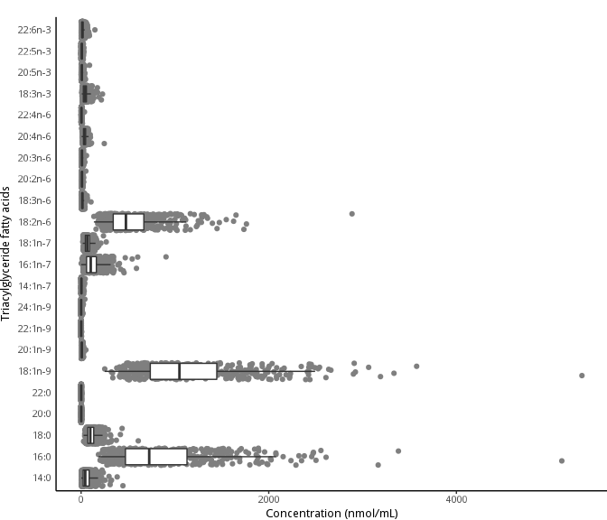

Figure 1: Distribution of the composition of triacylglycerol fatty acids in the baseline visit of PROMISE participants (2004-2006). Boxplots represent the median and interquartile range of the fatty acid values.

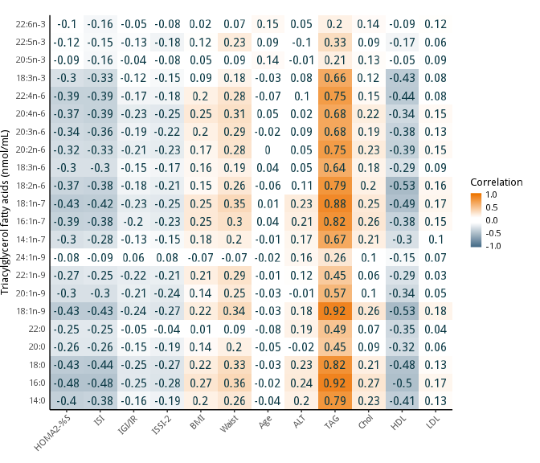

Figure 2: Pearson correlation heatmap of triacylglycerol fatty acids (nmol/mL) with continuous basic and metabolic characteristics of PROMISE participants from the baseline visit (2004-2006). Darker orange represents a positive correlation; darker blue represents a negative correlation.

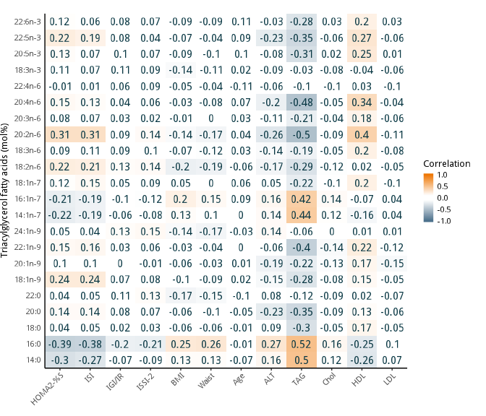

Figure 3: Pearson correlation heatmap of triacylglycerol fatty acids (mol%) with continuous basic and metabolic characteristics of PROMISE participants from the baseline visit (2004-2006). Darker orange represents a positive correlation; darker blue represents a negative correlation.

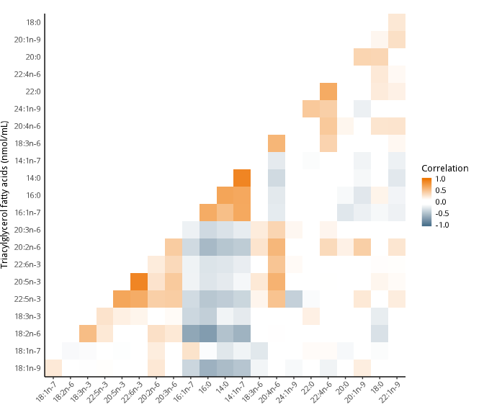

Figure 4: Pearson correlation heatmap of the triacylglycerol fatty acids in the PROMISE participants from the baseline visit (2004-2006). The correlations of fatty acids grouped using heirarchical cluster analysis; fatty acids along the x and y axis are ordered according to this analysis. Darker orange represents a positive correlation; darker blue represents a negative correlation. Correlation with what? WHY are fatty acids on both axes? HOW SHOULD THIS BE READ?

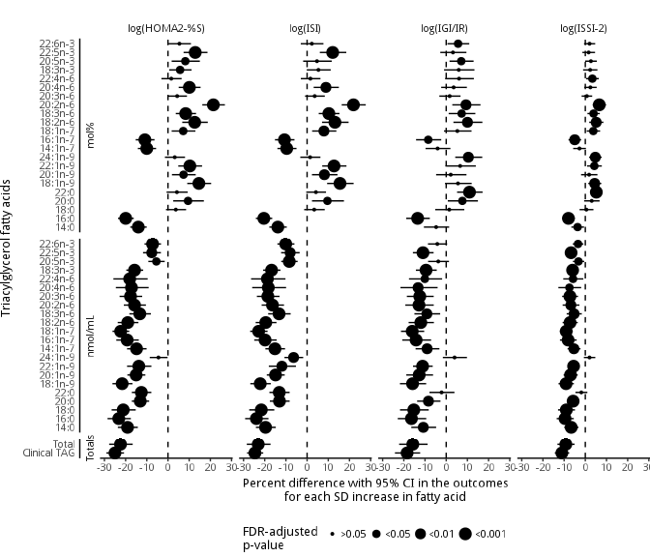

Figure 5: Time-adjusted GEE models of the association of the triacylglycerol fatty acids (mol% and nmol/mL) and total clinically-measured TAG with insulin sensitivity and beta-cell function outcomes using the 6 year longitudinal data from the PROMISE cohort. X-axis values represent a percent difference in the outcome per SD increase in the fatty acid. P-values were adjusted for the BH false discovery rate, with the largest dot representing a significant (p<0.05) association.

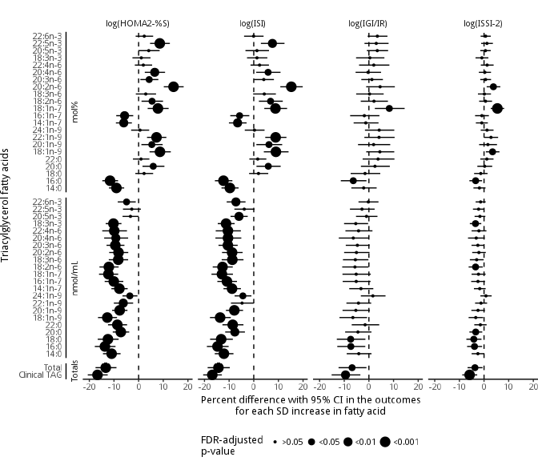

Figure 6: Fully-adjusted GEE models of the association of the triacylglycerol fatty acids (mol% and nmol/mL) and total clinically-measured TAG with insulin sensitivity and beta-cell function outcomes using the 6 year longitudinal data from the PROMISE cohort. Variables controlled for were follow-up time, waist circumference, baseline age, ethnicity, sex, ALT, physical activity, and total NEFA. X-axis values represent a percent difference in the outcome per SD increase in the fatty acid. P-values were adjusted for the BH false discovery rate, with the largest dot representing a significant (p<0.05) association.

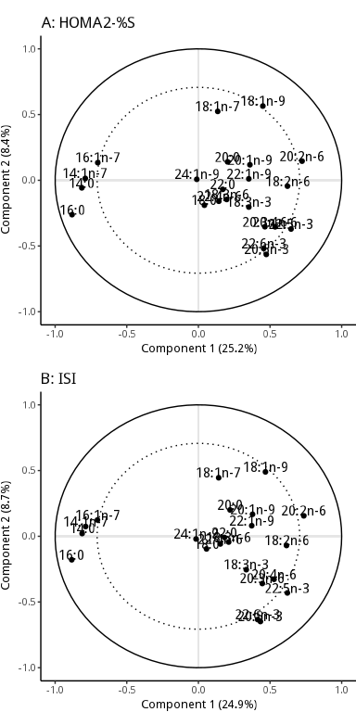

Figure 7: Partial least squares (PLS) models showing the clustering of triacylglycerol fatty acids on insulin sensitivity measures. The R value shown above the graph WHERE? is the correlation between predicted and observed values, using cross-validation; a higher value suggests the fatty acids strongly predict the metabolic outcome. The percent explained variance of each component is shown in brackets on each axis. WHAT DO THE AXES REPRESENT? EXPLAIN The solid line represents an explained variance of 100% while the dashed line represents an explained variance of 50%. Fatty acids between these lines represent variables that strongly explain the underlying structure of the data. See the Supplemental Methods for a description of PLS analysis and an explanation of interpreting this plot.

# Supplemental Material

## Supplemental Methods: Statistical analysis

Generalized estimating equations (GEE) is a technique similar to mixed effects modeling, except it calculates the marginal population estimates compared to the subject-specific estimates in mixed effects models. GEE is well suited to and commonly used in longitudinal cohort studies, especially given its capacity to handle missed visits.

The working correlation matrix for the GEE analysis was chosen based on quasi-likelihood information criteria (QIC). The auto-regressive of order 1 (AR1) matrix was chosen for the GEE models as it had the best model fit assessed using QIC, though other matrices (eg. exchangeable) had similar fit (data not shown).

For the confounders, they were chosen based on previous literature, from directed acyclic graph (DAG) (28) recommendationsQUOTE CAUSAL MODELING , and from QIC. The DAG recommendations were obtained from using the DAGitty software (46), <http://dagitty.net/>. See Supplemental Figure 2 and Supplemental Figure 3) for the DAG model. See Supplemental Table 1 for the comparison of various models with different covariates using QIC. While the final GEE model selected as best fitting differed between insulin sensitivity and beta-cell function measures WHICH ONE CHOSEN RESPECTIVELY? , the differences in the QIC values were less than 10 between many of the models, suggesting similar fit. As such, we selected the model that had the fewest covariates and that had similar fit between the outcome measures. Total NEFA was included as a confounder because it is used substantially as a source of fatty acids in hepatic TAG production (47).

No imputation was conducted on missing values. Prevalent cases of diabetes at baseline and incident cases at follow-up were excluded from the GEE analysis. The resulting GEE beta estimates were exponentiated to allow the interpretation as stated in the main methods.

PLS is a technique used for multivariate, high dimensionality datasets where there is a potential or likely underlying structure to the data. Because it uses a response variable (i.e. the outcome or y variable) when identifying the underlying structure it is known as a supervised statistical method, which gives it greater predictive power when using the model against updated or new data. PLS generates a number of components based on the number of variables provided. We used internal 10-fold cross-validation to determine which components to extract from the PLS analysis. Based on the internal cross-validation, the first two components gave the highest amount of explained variance (data not shown), of which we decided to use these two components in the final results.

The predictive capability of the PLS models were tested using cross-validation. The data set was randomly split in half into a training set and a testing set. After specifying the model on the training set, results were compared using the testing set to determine whether how predictive the model was given a new dataset. Final results shown in the figures use the full dataset (rather than a training or testing set). No prevalent diabetes cases were included in the PLS analysis. JARGON< EXPLAIN BETTER

## Supplemental Tables

Supplemental Table 1: Comparison of GEE model fitness for variable selection using quasi-likelihood information criteria.

|  |  |  |
| --- | --- | --- |
| Model | QIC | Delta |
| **log(ISI)** | NA | NA |
| M7 | -1651.5 | 0.0 |
| M8 | -1649.9 | 1.6 |
| M9 | -1646.9 | 4.6 |
| M5 | -1646.5 | 5.0 |
| M6 | -1643.9 | 7.6 |
| M4 | -1641.8 | 9.7 |
| M3 | -1619.1 | 32.4 |
| M1 | -1261.7 | 389.8 |
| M0 | -1258.3 | 393.2 |
| M2 | -1250.4 | 401.1 |
| **log(ISSI-2)** | NA | NA |
| M8 | -2591.9 | 0.0 |
| M9 | -2590.4 | 1.5 |
| M6 | -2584.8 | 7.1 |
| M7 | -2583.7 | 8.2 |
| M4 | -2573.7 | 18.2 |
| M5 | -2571.2 | 20.7 |
| M3 | -2566.2 | 25.7 |
| M2 | -2353.9 | 238.1 |
| M1 | -2301.4 | 290.5 |
| M0 | -2300.3 | 291.6 |

Given the number of possible combinations of outcome and predictor variables, only ISI and ISSI-2 with total triacylglycerol fatty acids (nmol/mL) were used to compare various GEE models and to select a final model. Baseline age was used as including both the original age and the time variable would result in collinearity. Column names: QIC is the quasi-likelihood information criteria (smaller values, eg. larger negative values, indicate a better fit compared to other models), Delta is the QIC minus the lowest QIC (models with delta <10 are considered equivalent). Models were:

* M0: log(ISSI-2) or log(ISI) = total triacylglycerol fatty acids (nmol/mL) + years from baseline
* M1: M0 + fatty acid by time interaction
* M2: M0 + sex + ethnicity + baseline age
* M3: M2 + waist
* M4: M3 + ALT
* M5: M4 + physical activity (MET)
* M6: M5 + total NEFA
* M7: M6 + alcohol intake
* M8: M7 + family history of diabetes
* M9: M8 + smoking status

Supplemental Table 2: Concentration (nmol/mL) and relative percent (mol%) values of triacylglycerol fatty acids in PROMISE participants at the baseline visit (2004-2006).

|  |  |  |
| --- | --- | --- |
| TAGFA | Concentrations (nmol/mL) | Proportion (mol%) |
| 18:3n-3 | 45.2 (31.1) | 1.5 (0.6) |
| 20:5n-3 | 9.9 (8.1) | 0.4 (0.4) |
| 22:5n-3 | 8.3 (5.7) | 0.3 (0.2) |
| 22:6n-3 | 16.7 (14.5) | 0.6 (0.6) |
| 18:2n-6 | 548.6 (298.7) | 18.0 (4.2) |
| 18:3n-6 | 15.1 (9.9) | 0.5 (0.2) |
| 20:2n-6 | 10.2 (4.7) | 0.4 (0.1) |
| 20:3n-6 | 10.2 (6.0) | 0.3 (0.1) |
| 20:4n-6 | 38.2 (19.1) | 1.3 (0.5) |
| 22:4n-6 | 4.6 (2.9) | 0.1 (0.1) |
| 14:1n-7 | 5.1 (6.1) | 0.1 (0.1) |
| 16:1n-7 | 126.1 (98.8) | 3.8 (1.3) |
| 18:1n-7 | 71.6 (34.8) | 2.4 (0.4) |
| 18:1n-9 | 1168.5 (592.2) | 37.8 (3.7) |
| 20:1n-9 | 8.5 (5.2) | 0.3 (0.2) |
| 22:1n-9 | 1.0 (0.6) | 0.0 (0.0) |
| 24:1n-9 | 2.2 (4.0) | 0.1 (0.1) |
| 14:0 | 62.4 (59.0) | 1.8 (1.0) |
| 16:0 | 868.0 (556.2) | 26.6 (4.4) |
| 18:0 | 113.6 (63.4) | 3.7 (0.8) |
| 20:0 | 1.9 (1.3) | 0.1 (0.0) |
| 22:0 | 1.5 (1.2) | 0.1 (0.0) |
| Total | 3137.5 (1686.6) |  |

Supplemental Table 3: Raw estimates and confidence interval values for *time*-adjusted GEE models of the association of the triacylglycerol fatty acids (mol% and nmol/mL) and total clinically-measured TAG with insulin sensitivity and beta-cell function outcomes using the 6 year longitudinal data from the PROMISE cohort. Estimates represent a percent difference in the outcome per SD increase in the fatty acid. P-values were adjusted for the BH false discovery rate, with an asterisk (*) denoting a significant (p<0.05) association.

|  |  |  |  |  |
| --- | --- | --- | --- | --- |
| Fatty acid | log(HOMA2-%S) | log(ISI) | log(IGI/IR) | log(ISSI-2) |
| **Totals** |  |  |  |  |
| Clinical TAG | -25.0 (-29.1, -20.8)* | -24.6 (-28.4, -20.7)* | -18.5 (-24.2, -12.3)* | -11.1 (-14.4, -7.6)* |
| Total | -22.4 (-27.8, -16.7)* | -23.1 (-28.5, -17.2)* | -15.8 (-22.2, -8.8)* | -9.2 (-13.2, -5.1)* |
| **nmol/mL** |  |  |  |  |
| 14:0 | -19.1 (-23.7, -14.2)* | -19.6 (-24.2, -14.8)* | -10.8 (-16.5, -4.7)* | -6.7 (-10.0, -3.2)* |
| 16:0 | -23.2 (-28.5, -17.5)* | -23.9 (-29.2, -18.2)* | -16.4 (-22.9, -9.4)* | -9.6 (-13.5, -5.4)* |
| 18:0 | -21.1 (-26.6, -15.2)* | -21.6 (-27.3, -15.5)* | -15.3 (-21.8, -8.2)* | -9.0 (-12.9, -4.9)* |
| 20:0 | -13.1 (-17.1, -8.9)* | -13.0 (-17.6, -8.2)* | -8.4 (-13.7, -2.7)* | -5.7 (-8.6, -2.8)* |
| 22:0 | -12.6 (-17.1, -7.9)* | -13.1 (-17.8, -8.2)* | -2.2 (-7.9, 3.9) | -1.9 (-4.7, 1.0) |
| 18:1n-9 | -21.6 (-26.2, -16.8)* | -22.1 (-26.8, -17.1)* | -15.9 (-21.8, -9.5)* | -9.1 (-12.6, -5.4)* |
| 20:1n-9 | -15.0 (-19.2, -10.7)* | -14.9 (-19.0, -10.6)* | -12.7 (-18.8, -6.2)* | -7.0 (-10.2, -3.6)* |
| 22:1n-9 | -13.8 (-19.3, -7.8)* | -11.9 (-18.1, -5.3)* | -11.1 (-15.7, -6.4)* | -5.5 (-8.1, -2.9)* |
| 24:1n-9 | -4.5 (-8.6, -0.2) | -6.4 (-10.7, -1.8)* | 4.0 (-1.6, 9.8) | 2.0 (-0.7, 4.7) |
| 14:1n-7 | -14.8 (-19.3, -10.1)* | -15.2 (-19.7, -10.4)* | -9.0 (-14.4, -3.2)* | -5.4 (-8.4, -2.3)* |
| 16:1n-7 | -19.3 (-24.4, -13.8)* | -19.8 (-25.0, -14.4)* | -14.2 (-20.7, -7.1)* | -8.1 (-12.0, -4.1)* |
| 18:1n-7 | -22.3 (-26.2, -18.3)* | -22.9 (-26.9, -18.7)* | -16.0 (-21.3, -10.4)* | -9.0 (-12.0, -5.9)* |
| 18:2n-6 | -19.0 (-23.7, -14.0)* | -19.5 (-24.3, -14.4)* | -12.0 (-17.7, -5.8)* | -7.2 (-10.7, -3.6)* |
| 18:3n-6 | -13.3 (-18.2, -8.1)* | -13.2 (-18.4, -7.8)* | -9.1 (-15.0, -2.8)* | -5.3 (-8.8, -1.7)* |
| 20:2n-6 | -15.8 (-20.9, -10.4)* | -16.3 (-21.5, -10.9)* | -12.8 (-19.3, -5.9)* | -6.8 (-10.7, -2.8)* |
| 20:3n-6 | -17.7 (-22.8, -12.2)* | -18.5 (-23.7, -13.0)* | -12.5 (-18.6, -5.9)* | -7.3 (-10.9, -3.4)* |
| 20:4n-6 | -17.2 (-24.6, -9.1)* | -18.3 (-25.9, -9.9)* | -13.3 (-21.6, -4.1)* | -7.5 (-12.7, -1.9)* |
| 22:4n-6 | -18.1 (-25.8, -9.6)* | -18.7 (-26.4, -10.2)* | -10.1 (-17.6, -1.9)* | -5.8 (-10.4, -0.9)* |
| 18:3n-3 | -15.8 (-19.7, -11.7)* | -16.8 (-20.7, -12.6)* | -9.5 (-14.3, -4.5)* | -6.0 (-8.6, -3.3)* |
| 20:5n-3 | -5.5 (-9.3, -1.5)* | -8.4 (-12.2, -4.5)* | -3.7 (-8.5, 1.3) | -3.2 (-5.8, -0.5)* |
| 22:5n-3 | -7.7 (-11.8, -3.3)* | -8.0 (-12.3, -3.5)* | -11.0 (-15.7, -5.9)* | -6.7 (-9.1, -4.2)* |
| 22:6n-3 | -7.3 (-11.1, -3.3)* | -10.1 (-14.0, -6.0)* | -4.2 (-8.6, 0.4) | -3.4 (-5.9, -0.9)* |
| **mol%** |  |  |  |  |
| 14:0 | -14.0 (-17.8, -10.0)* | -13.8 (-17.8, -9.6)* | -4.8 (-10.5, 1.4) | -3.6 (-6.6, -0.6)* |
| 16:0 | -20.0 (-23.6, -16.2)* | -20.4 (-24.2, -16.5)* | -13.5 (-18.9, -7.7)* | -8.0 (-10.9, -5.0)* |
| 18:0 | 3.7 (-0.9, 8.6) | 3.4 (-1.4, 8.3) | 1.4 (-5.2, 8.5) | 0.5 (-2.7, 3.8) |
| 20:0 | 9.5 (2.5, 16.9)* | 9.6 (2.3, 17.4)* | 7.6 (0.8, 15.0)* | 3.0 (-0.6, 6.7) |
| 22:0 | 4.2 (-0.7, 9.3) | 4.2 (-0.4, 8.9) | 11.0 (5.1, 17.2)* | 5.2 (2.6, 7.9)* |
| 18:1n-9 | 14.6 (9.1, 20.4)* | 15.5 (9.5, 22.0)* | 5.6 (-0.5, 12.0) | 4.4 (1.4, 7.5)* |
| 20:1n-9 | 7.3 (1.9, 13.1)* | 8.2 (2.3, 14.4)* | 2.1 (-4.8, 9.6) | 1.8 (-2.0, 5.7) |
| 22:1n-9 | 10.3 (4.8, 16.1)* | 12.7 (7.1, 18.6)* | 6.6 (-0.3, 14.0) | 4.3 (0.8, 7.8)* |
| 24:1n-9 | 3.2 (-1.5, 8.0) | 1.4 (-3.2, 6.3) | 10.5 (4.3, 17.0)* | 4.7 (1.8, 7.8)* |
| 14:1n-7 | -10.0 (-14.2, -5.6)* | -9.6 (-14.0, -5.0)* | -4.1 (-9.7, 2.0) | -2.8 (-5.7, 0.3) |
| 16:1n-7 | -10.9 (-15.2, -6.4)* | -10.7 (-15.2, -6.0)* | -8.5 (-14.2, -2.3)* | -5.0 (-7.9, -1.9)* |
| 18:1n-7 | 7.2 (1.7, 12.9)* | 7.9 (2.4, 13.8)* | 5.3 (-1.0, 12.0) | 3.8 (0.7, 7.0)* |
| 18:2n-6 | 12.6 (6.7, 18.8)* | 13.1 (7.1, 19.6)* | 10.0 (3.4, 17.1)* | 5.1 (1.9, 8.5)* |
| 18:3n-6 | 8.4 (3.7, 13.2)* | 10.3 (5.5, 15.3)* | 7.3 (1.2, 13.8)* | 3.9 (1.0, 6.9)* |
| 20:2n-6 | 21.4 (16.2, 26.9)* | 21.9 (16.3, 27.7)* | 9.3 (2.9, 16.2)* | 6.6 (3.5, 9.8)* |
| 20:3n-6 | 4.3 (-0.1, 9.0) | 3.6 (-1.0, 8.4) | 1.6 (-3.2, 6.8) | 0.7 (-1.7, 3.2) |
| 20:4n-6 | 10.1 (5.0, 15.4)* | 8.9 (3.1, 15.0)* | 3.5 (-2.4, 9.8) | 2.4 (-0.5, 5.4) |
| 22:4n-6 | 1.6 (-3.1, 6.4) | 1.6 (-3.0, 6.3) | 6.1 (-0.5, 13.1) | 3.3 (0.4, 6.4)* |
| 18:3n-3 | 5.7 (0.6, 11.1)* | 5.3 (-0.2, 11.2) | 5.9 (-1.0, 13.3) | 2.3 (-1.0, 5.7) |
| 20:5n-3 | 8.2 (1.7, 15.0)* | 4.7 (-1.9, 11.6) | 7.1 (1.6, 12.9)* | 2.6 (-0.1, 5.4) |
| 22:5n-3 | 12.9 (7.4, 18.6)* | 12.1 (6.0, 18.5)* | 3.2 (-2.8, 9.5) | 1.6 (-1.4, 4.6) |
| 22:6n-3 | 5.4 (0.2, 10.8) | 2.2 (-3.0, 7.7) | 5.6 (0.6, 10.9)* | 2.0 (-0.6, 4.7) |

Supplemental Table 4: Raw estimates and confidence interval values for *fully*-adjusted GEE models of the association of the triacylglycerol fatty acids (mol% and nmol/mL) and total clinically-measured TAG with insulin sensitivity and beta-cell function outcomes using the 6 year longitudinal data from the PROMISE cohort. Variables controlled for were follow-up time, waist circumference, baseline age, ethnicity, sex, ALT, physical activity, and total NEFA. Estimates represent a percent difference in the outcome per SD increase in the fatty acid. P-values were adjusted for the BH false discovery rate, with an asterisk (*) denoting a significant (p<0.05) association.

|  |  |  |  |  |
| --- | --- | --- | --- | --- |
| Fatty acid | log(HOMA2-%S) | log(ISI) | log(IGI/IR) | log(ISSI-2) |
| **Totals** |  |  |  |  |
| Clinical TAG | -16.7 (-20.6, -12.5)* | -16.8 (-20.5, -12.9)* | -9.5 (-15.1, -3.5)* | -5.9 (-8.8, -2.8)* |
| Total | -13.3 (-17.5, -9.0)* | -14.3 (-18.7, -9.7)* | -6.8 (-12.3, -1.0)* | -3.7 (-6.7, -0.6)* |
| **nmol/mL** |  |  |  |  |
| 14:0 | -11.0 (-14.5, -7.3)* | -12.1 (-15.8, -8.2)* | -4.1 (-9.0, 1.0) | -2.5 (-5.0, 0.1) |
| 16:0 | -13.7 (-17.8, -9.4)* | -14.7 (-19.0, -10.2)* | -7.3 (-12.8, -1.5)* | -3.9 (-6.9, -0.8)* |
| 18:0 | -12.5 (-16.6, -8.1)* | -13.2 (-17.7, -8.5)* | -7.4 (-13.0, -1.4)* | -4.1 (-7.2, -1.0)* |
| 20:0 | -7.2 (-10.5, -3.8)* | -7.7 (-11.6, -3.6)* | -4.5 (-9.6, 1.0) | -3.4 (-5.9, -0.7)* |
| 22:0 | -8.6 (-12.4, -4.7)* | -8.5 (-12.7, -4.2)* | -1.5 (-7.0, 4.2) | -1.5 (-4.0, 1.0) |
| 18:1n-9 | -12.7 (-16.5, -8.8)* | -13.6 (-17.8, -9.3)* | -6.5 (-11.9, -0.7) | -3.4 (-6.3, -0.4) |
| 20:1n-9 | -7.7 (-10.7, -4.5)* | -7.9 (-11.3, -4.3)* | -5.3 (-10.7, 0.4) | -2.4 (-5.1, 0.3) |
| 22:1n-9 | -6.2 (-10.1, -2.2)* | -4.8 (-9.3, 0.0) | -4.2 (-9.1, 0.9) | -1.2 (-3.6, 1.2) |
| 24:1n-9 | -3.6 (-6.5, -0.5)* | -4.4 (-7.8, -1.0)* | 1.6 (-3.3, 6.7) | 0.8 (-1.5, 3.1) |
| 14:1n-7 | -7.8 (-11.1, -4.4)* | -8.8 (-12.3, -5.2)* | -3.2 (-8.0, 1.8) | -1.8 (-4.1, 0.6) |
| 16:1n-7 | -10.1 (-13.8, -6.2)* | -10.9 (-14.8, -6.8)* | -5.1 (-10.6, 0.7) | -2.5 (-5.2, 0.4) |
| 18:1n-7 | -12.3 (-16.1, -8.3)* | -12.9 (-17.2, -8.5)* | -5.2 (-10.7, 0.8) | -2.3 (-5.1, 0.6) |
| 18:2n-6 | -12.1 (-15.9, -8.1)* | -12.7 (-16.7, -8.5)* | -5.7 (-10.8, -0.2) | -3.4 (-6.3, -0.5)* |
| 18:3n-6 | -8.3 (-12.1, -4.3)* | -8.7 (-13.0, -4.2)* | -5.5 (-10.5, -0.2) | -3.0 (-5.7, -0.2) |
| 20:2n-6 | -8.2 (-11.9, -4.2)* | -8.8 (-12.9, -4.5)* | -5.0 (-10.1, 0.2) | -2.1 (-4.8, 0.7) |
| 20:3n-6 | -9.5 (-13.0, -5.8)* | -10.5 (-14.3, -6.5)* | -4.7 (-9.4, 0.3) | -2.5 (-5.1, 0.1) |
| 20:4n-6 | -9.3 (-14.0, -4.3)* | -10.5 (-15.6, -5.0)* | -6.3 (-12.2, -0.1) | -3.2 (-6.5, 0.3) |
| 22:4n-6 | -9.9 (-14.8, -4.7)* | -10.5 (-15.4, -5.2)* | -4.2 (-9.5, 1.4) | -2.1 (-5.0, 1.0) |
| 18:3n-3 | -10.2 (-13.4, -7.0)* | -11.2 (-14.6, -7.8)* | -5.3 (-10.1, -0.3) | -3.5 (-5.8, -1.1)* |
| 20:5n-3 | -3.3 (-6.5, 0.0) | -6.0 (-9.4, -2.4)* | -1.0 (-5.2, 3.5) | -1.7 (-3.8, 0.5) |
| 22:5n-3 | -2.8 (-6.3, 0.9) | -3.9 (-7.9, 0.3) | -2.8 (-7.7, 2.3) | -2.2 (-4.5, 0.1) |
| 22:6n-3 | -4.9 (-8.5, -1.2)* | -7.2 (-11.0, -3.3)* | -0.2 (-4.2, 3.9) | -1.4 (-3.4, 0.7) |
| **mol%** |  |  |  |  |
| 14:0 | -9.0 (-12.0, -5.9)* | -9.7 (-13.1, -6.2)* | -2.1 (-7.1, 3.1) | -1.9 (-4.3, 0.6) |
| 16:0 | -11.6 (-14.7, -8.3)* | -12.3 (-15.8, -8.7)* | -6.3 (-11.4, -1.0)* | -3.4 (-5.9, -0.8)* |
| 18:0 | 2.2 (-1.3, 5.9) | 1.9 (-1.9, 5.9) | -1.6 (-7.4, 4.6) | -1.3 (-4.0, 1.4) |
| 20:0 | 5.9 (1.6, 10.5)* | 5.9 (1.1, 10.9)* | 2.5 (-3.2, 8.5) | 0.3 (-2.7, 3.3) |
| 22:0 | 1.0 (-2.3, 4.4) | 1.6 (-1.8, 5.1) | 3.7 (-2.5, 10.4) | 1.1 (-1.5, 3.8) |
| 18:1n-9 | 8.7 (4.4, 13.1)* | 9.0 (4.1, 14.1)* | 4.4 (-1.1, 10.3) | 3.5 (0.7, 6.3)* |
| 20:1n-9 | 5.4 (1.1, 9.8)* | 6.2 (1.1, 11.5)* | 1.9 (-4.4, 8.7) | 1.6 (-2.0, 5.3) |
| 22:1n-9 | 7.3 (3.4, 11.3)* | 8.9 (4.7, 13.3)* | 4.1 (-1.8, 10.4) | 2.8 (0.0, 5.7) |
| 24:1n-9 | 0.6 (-3.0, 4.3) | 0.3 (-3.6, 4.4) | 4.2 (-1.6, 10.3) | 1.2 (-1.3, 3.9) |
| 14:1n-7 | -6.0 (-9.2, -2.7)* | -6.6 (-10.1, -2.9)* | -1.3 (-6.2, 3.9) | -0.9 (-3.3, 1.5) |
| 16:1n-7 | -5.7 (-9.1, -2.2)* | -5.8 (-9.5, -1.8)* | -1.9 (-7.6, 4.3) | -0.9 (-3.6, 2.0) |
| 18:1n-7 | 7.8 (3.7, 12.2)* | 8.8 (4.3, 13.5)* | 8.3 (2.4, 14.5)* | 5.4 (2.7, 8.2)* |
| 18:2n-6 | 5.4 (1.2, 9.9)* | 6.8 (2.1, 11.8)* | 2.1 (-3.3, 7.7) | 0.6 (-2.0, 3.3) |
| 18:3n-6 | 2.9 (-1.1, 7.1) | 4.3 (-0.2, 9.0) | 0.3 (-5.2, 6.0) | 0.1 (-2.5, 2.8) |
| 20:2n-6 | 14.2 (10.2, 18.3)* | 15.2 (10.8, 19.9)* | 4.5 (-1.1, 10.5) | 3.8 (1.1, 6.6)* |
| 20:3n-6 | 4.3 (0.7, 8.0)* | 4.1 (0.1, 8.2) | 1.2 (-3.1, 5.7) | 0.6 (-1.5, 2.8) |
| 20:4n-6 | 6.5 (2.5, 10.7)* | 5.8 (1.0, 10.9)* | -0.4 (-5.4, 4.9) | 0.3 (-2.1, 2.8) |
| 22:4n-6 | 1.9 (-1.5, 5.5) | 2.4 (-1.3, 6.2) | 2.0 (-4.0, 8.3) | 1.3 (-1.3, 3.9) |
| 18:3n-3 | 1.1 (-2.5, 4.8) | 1.3 (-2.7, 5.5) | 0.4 (-5.2, 6.3) | -0.9 (-3.5, 1.8) |
| 20:5n-3 | 4.1 (-0.1, 8.5) | 1.3 (-3.4, 6.2) | 3.4 (-0.8, 7.8) | 0.6 (-1.5, 2.7) |
| 22:5n-3 | 8.6 (4.6, 12.7)* | 7.6 (2.9, 12.5)* | 3.0 (-1.8, 8.0) | 1.2 (-1.2, 3.6) |
| 22:6n-3 | 2.3 (-1.2, 5.9) | -0.1 (-3.9, 4.0) | 3.4 (-0.5, 7.5) | 0.7 (-1.4, 2.7) |

## Supplemental Figures

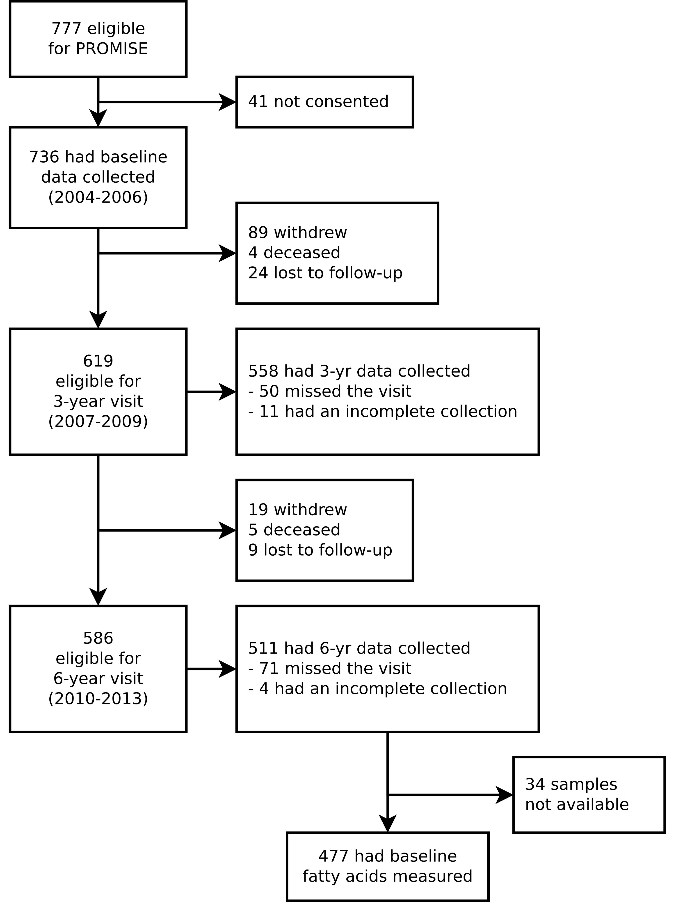

Supplemental Figure 1: CONSORT diagram of PROMISE participants over the 3 visits.

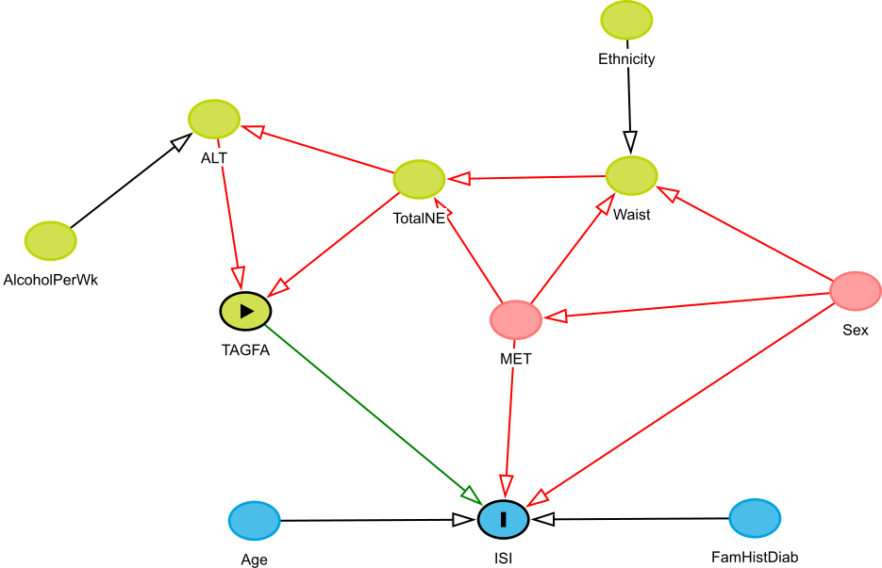

Supplemental Figure 2: Directed acyclic graphic output from the DAGitty online software for insulin sensitivity. NOT CLEAR IS THIS FROM YOUR DATA OR FROM LITERATURE (SAME FOR Supplemental Fig.2)

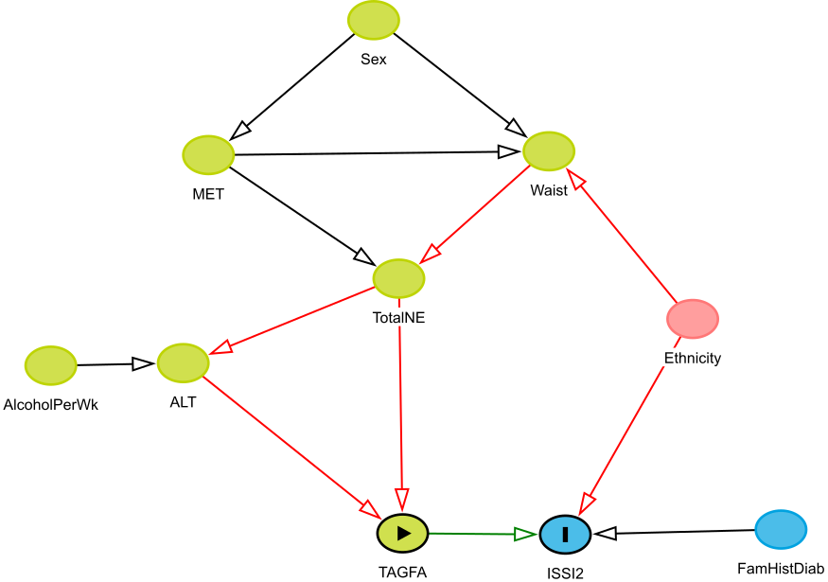

Supplemental Figure 3: Directed acyclic graphic output from the DAGitty online software for beta-cell function.

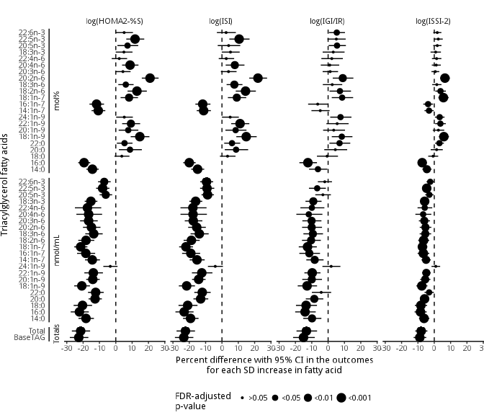

Supplemental Figure 4: Fully-adjusted (without waist size) GEE models of the association of the triacylglycerol fatty acids (mol% and nmol/mL) and total clinically-measured TAG with insulin sensitivity and beta-cell function outcomes using the 6 year longitudinal data from the PROMISE cohort. Variables controlled for were follow-up time, baseline age, ethnicity, sex, ALT, physical activity, and total NEFA. X-axis values represent a percent difference in the outcome per SD increase in the fatty acid. P-values were adjusted for the BH false discovery rate, with the largest dot representing a significant (p<0.05) association.

# References

1. Chehade JM, Gladysz M, Mooradian AD. Dyslipidemia in type 2 diabetes: Prevalence, pathophysiology, and management. Drugs. 2013;73(4):327–39.

2. D’Agostino RB, Hamman RF, Karter AJ, Mykkanen L, Wagenknecht LE, Haffner SM. Cardiovascular Disease Risk Factors Predict the Development of Type 2 Diabetes: The Insulin Resistance Atherosclerosis Study. Diabetes Care. 2004 Aug;27(9):2234–40.

3. Vergès B. Pathophysiology of diabetic dyslipidaemia: Where are we? Diabetologia. 2015;58(5):886–99.

4. Kawano Y, Cohen DE. Mechanisms of hepatic triglyceride accumulation in non-alcoholic fatty liver disease. J Gastroenterol. 2013;48(4):434–41.

5. Alberti K, Eckel RH, Grundy SM, Zimmet PZ, Cleeman JI, Donato KA, et al. Harmonizing the Metabolic Syndrome: A Joint Interim Statement of the International Diabetes Federation Task Force on Epidemiology and Prevention; National Heart, Lung, and Blood Institute; American Heart Association; World Heart Federation; International Atherosclerosis Society; and International Association for the Study of Obesity. Circulation. 2009;120(16):1640–5.

6. Lemieux I, Pascot A, Couillard C, Lamarche B, Tchernof A, Alméras N, et al. Hypertriglyceridemic waist: A marker of the atherogenic metabolic triad (hyperinsulinemia; hyperapolipoprotein b; small, dense ldl) in men? Circulation. 2000 Jul;102(2):179–84.

7. Forouhi NG, Koulman A, Sharp SJ, Imamura F, Kröger J, Schulze MB, et al. Differences in the prospective association between individual plasma phospholipid saturated fatty acids and incident type 2 diabetes: The EPIC-InterAct case-cohort study. Lancet Diabetes Endocrinol. 2014 Oct;2(10):810–8.

8. Ma W, Wu JHY, Wang Q, Lemaitre RN, Mukamal KJ, Djoussé L, et al. Prospective association of fatty acids in the de novo lipogenesis pathway with risk of type 2 diabetes: The Cardiovascular Health Study. Am J Clin Nutr. 2015 Jan;101(1):153–63.

9. Johnston LW, Harris SB, Retnakaran R, Zinman B, Giacca A, Liu Z, et al. Longitudinal associations of phospholipid and cholesteryl ester fatty acids with disorders underlying diabetes. J Clin Endocrinol Metab. 2016 May;jc20154267.

10. Rhee EP, Cheng S, Larson MG, Walford GA, Lewis GD, McCabe E, et al. Lipid profiling identifies a triacylglycerol signature of insulin resistance and improves diabetes prediction in humans. J Clin Invest. 2011;121(4):1402–11.

11. Lankinen MA, Stančáková A, Uusitupa M, Ågren J, Pihlajamäki J, Kuusisto J, et al. Plasma fatty acids as predictors of glycaemia and type 2 diabetes. Diabetologia. 2015;[Epub ahead of print].

12. Yu SS, Castillo DC, Courville AB, Sumner AE. The triglyceride paradox in people of African descent. Metab Syndr Relat Disord. 2012;10(2):77–82.

13. Chien K, Cai T, Hsu H, Su T, Chang W, Chen M, et al. A prediction model for type 2 diabetes risk among Chinese people. Diabetologia. 2008 Dec;52(3):443–50.

14. Schulze MB, Weikert C, Pischon T, Bergmann MM, Al-Hasani H, Schleicher E, et al. Use of Multiple Metabolic and Genetic Markers to Improve the Prediction of Type 2 Diabetes: The EPIC-Potsdam Study. Diabetes Care. 2009 Aug;32(11):2116–9.

15. WHO, IDF. Definition and diagnosis of diabetes mellitus and intermediate hyperglycaemia: Report of a WHO/IDF consultation. 2006.

16. Matthan NR, Ip B, Resteghini N, Ausman LM, Lichtenstein AH. Long-term fatty acid stability in human serum cholesteryl ester, triglyceride, and phospholipid fractions. J Lipid Res. 2010 Sep;51(9):2826–32.

17. Folch J, Lees M, Sloane Stanley GH. A simple method for the isolation and purification of total lipides from animal tissues. J Biol Chem. 1957;226(1):497–509.

18. Nishi S, Kendall CWC, Gascoyne A-M, Bazinet RP, Bashyam B, Lapsley KG, et al. Effect of almond consumption on the serum fatty acid profile: A dose-response study. Br J Nutr. 2014 Oct;112(7):1137–46.

19. Kriska A, Knowler W, LaPorte R, Drash A, Wing R, Blair S, et al. Development of questionnaire to examine relationship of physical activity and diabetes in Pima Indians. Diabetes Care. 1990;13(4):401–11.

20. Matsuda M, DeFronzo R. Insulin sensitivity indices obtained from oral glucose tolerance testing: Comparison with the euglycemic insulin clamp. Diabetes Care. 1999;22(9):1462–70.

21. Levy JC, Matthews DR, Hermans MP. Correct Homeostasis Model Assessment (HOMA) Evaluation Uses the Computer Program. Diabetes Care. 1998 Dec;21(12):2191–2.

22. Abdul-Ghani M, Matsuda M, Balas B, DeFronzo R. Muscle and liver insulin resistance indexes derived from the oral glucose tolerance test. Diabetes Care. 2007;30(1):89–94.

23. Wareham N, Phillips D, Byrne C, Hales C. The 30 minute insulin incremental response in an oral glucose tolerance test as a measure of insulin secretion. Diabet Med. 1995;12(10):931.

24. Matthews D, Hosker J, Rudenski A. Homeostasis model assessment: Insulin resistance and beta-cell function from fasting plasma glucose and insulin concentrations in man. Diabetologia. 1985;28(7):412–9.

25. Retnakaran R, Qi Y, Goran M, Hamilton J. Evaluation of proposed oral disposition index measures in relation to the actual disposition index. Diabet Med. 2009;26(12):1198–203.

26. Hermans MP, Levy JC, Morris RJ, Turner RC. Comparison of insulin sensitivity tests across a range of glucose tolerance from normal to diabetes. Diabetologia. 1999 May;42(6):678–87.

27. Zeger SL, Liang KY. Longitudinal data analysis for discrete and continuous outcomes. Biometrics. 1986 Mar;42(1):121–30.

28. Greenland S, Pearl J, Robins JM. Causal diagrams for epidemiologic research. Epidemiology. 1999;10(1):37–48.

29. R Core Team. R: A Language and Environment for Statistical Computing [Internet]. Vienna, Austria: R Foundation for Statistical Computing; 2015. Available from: <http://www.R-project.org/>

30. Højsgaard S, Halekoh U, Yan J. The R Package geepack for Generalized Estimating Equations. Journal of Statistical Software. 2006;15/2:1–11.

31. Benjamini Y, Hochberg Y. Controlling the False Discovery Rate: A Practical and Powerful Approach to Multiple Testing. J R Stat Soc Series B Stat Methodol [Internet]. 1995;57(1):289–300. Available from: <http://www.jstor.org/stable/2346101>

32. Vandenbroucke JP, von Elm E, Altman DG, Gøtzsche PC, Mulrow CD, Pocock SJ, et al. Strengthening the Reporting of Observational Studies in Epidemiology (STROBE): Explanation and elaboration. PLoS Med. 2007 Oct;4(10):e297.

33. Hodson L, Skeaff CM, Fielding BA. Fatty acid composition of adipose tissue and blood in humans and its use as a biomarker of dietary intake. Prog Lipid Res. 2008;47(5):348–80.

34. Kotronen A, Velagapudi VR, Yetukuri L, Westerbacka J, Bergholm R, Ekroos K, et al. Serum saturated fatty acids containing triacylglycerols are better markers of insulin resistance than total serum triacylglycerol concentrations. Diabetologia. 2009;52(4):684–90.

35. Harding SV, Bateman KP, Kennedy BP, Rideout TC, Jones PJH. Desaturation index versus isotopically measured de novo lipogenesis as an indicator of acute systemic lipogenesis. 2015;8:49.

36. Hudgins LC. Effect of high-carbohydrate feeding on triglyceride and saturated fatty acid synthesis. Proc Soc Exp Biol Med. 2000;225(3):178–83.

37. Parks EJ, Krauss RM, Christiansen MP, Neese RA, Hellerstein MK. Effects of a low-fat, high-carbohydrate diet on VLDL-triglyceride assembly, production, and clearance. J Clin Invest. 1999;104(8):1087–96.

38. Zong G, Zhu J, Sun L, Ye X, Lu L, Jin Q, et al. Associations of erythrocyte fatty acids in the de novo lipogenesis pathway with risk of metabolic syndrome in a cohort study of middle-aged and older Chinese. Am J Clin Nutr. 2013;98(2):319–26.

39. Kröger J, Zietemann V, Enzenbach C, Weikert C, Jansen EH, Döring F, et al. Erythrocyte membrane phospholipid fatty acids, desaturase activity, and dietary fatty acids in relation to risk of type 2 diabetes in the European Prospective Investigation into Cancer and Nutrition (EPIC)-Potsdam Study. Am J Clin Nutr. 2011;93(1):127–42.

40. Lee JJ, Lambert JE, Hovhannisyan Y, Ramos-Roman MA, Trombold JR, Wagner DA, et al. Palmitoleic acid is elevated in fatty liver disease and reflects hepatic lipogenesis. Am J Clin Nutr. 2015 Jan;101(1):34–43.

41. Wilke MS, French MA, Goh YK, Ryan EA, Jones PJ, Clandinin MT. Synthesis of specific fatty acids contributes to VLDL-triacylglycerol composition in humans with and without type 2 diabetes. Diabetologia. 2009;52(8):1628–37.

42. Risérus U. Fatty acids and insulin sensitivity. Curr Opin Clin Nutr Metab Care. 2008;11(2):100–5.

43. Iggman D, Arnlöv J, Vessby B, Cederholm T, Sjögren P, Risérus U. Adipose tissue fatty acids and insulin sensitivity in elderly men. Diabetologia. 2010;53(5):850–7.

44. Flannery C, Dufour S, Rabøl R, Shulman GI, Petersen KF. Skeletal muscle insulin resistance promotes increased hepatic de novo lipogenesis, hyperlipidemia, and hepatic steatosis in the elderly. Diabetes. 2012;61(11):2711–7.

45. Schwab U, Seppänen-Laakso T, Yetukuri L, Agren J, Kolehmainen M, Laaksonen DE, et al. Triacylglycerol fatty acid composition in diet-induced weight loss in subjects with abnormal glucose metabolism–the GENOBIN study. PLoS ONE. 2008;3(7):e2630.

46. Textor J, Hardt J, Knüppel S. DAGitty: A graphical tool for analyzing causal diagrams. Epidemiology. 2011 Sep;22(5):745.

47. Barrows BR, Parks EJ. Contributions of different fatty acid sources to very low-density lipoprotein-triacylglycerol in the fasted and fed states. J Clin Endocrinol Metab. 2006;91(4):1446–52.